Shabbos Stories for
Parshas ki seitzei 5779
Volume 10, Issue 56 14 Elul/ September 14, 2019
Printed L’illuy nishmas Nechama bas R’ Noach, a”h

For a free subscription, please forward your request to keren18@juno.com

The Learned Thief, the Studious Visitor, and
The Kind Innkeeper
By Asharon Baltazar

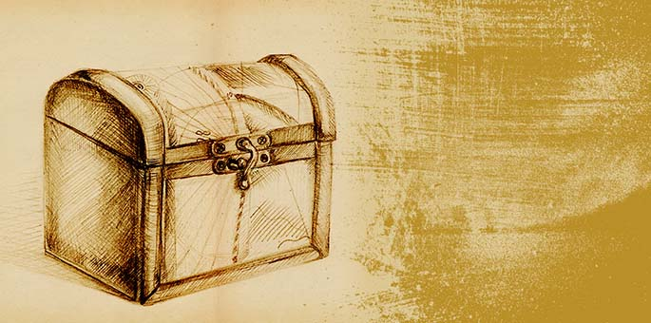
Illustration by Rivka Korf

“Oh please help me, Rebbe,” beseeched the chassid, quietly blinking back tears. “My daughter is at last betrothed to a fine young man, but I haven’t even a glimmer of an idea of how I’ll be able to pay for the wedding.”
Rabbi Yaakov Yitzchak Horowitz, the Seer of Lublin, directed his eyes heavenward. “Your help lies in G-d’s hands and nowhere else. Travel to such-and-such a town and book a room at the local inn. You should sit and study Torah there, and G-d will deliver the necessary help.”
Doubts quieted, the chassid left the room, went home to pack a few essentials, and immediately began his journey to the specified town. The rabbi’s words buoyed his heart and spirit.
He found a Jewish-owned inn and checked into a room, perhaps indefinitely. Holed up all day studying, his lack of activity stirred the innkeeper’s curiosity. On one of his rare ventures through the foyer, the innkeeper detained him and politely asked about this behavior.
The chassid didn’t hide the intent of his stay and told the innkeeper all about the rebbe’s promise which he believed with all his heart. A friendship took root, and the two opened up more and more about their lives.
Feeling particularly comfortable one evening, the innkeeper confided:
“I used to be a rich man, blessed with an abundance of wealth. Unfortunately, I lost it all in less than an hour, just after I returned home from the Leipzig fair 20 years ago.
“I had finished counting my earnings, arranging the bills and coins in neat, labeled stacks when a sudden errand demanded my attention and I left the safe unlocked and unattended. You can imagine my shock when I returned to find the empty box sitting on my desk.
“My head spun. This was all I had! The room looked exactly as I had left it, without a trace of forced entry. I suspected my servant and demanded that he confess, but when I saw his bewilderedness I had to abandon any further inquiry. I had no evidence and didn’t want to wrongly accuse anyone.
“Now this inn is my sole source of income, but I don’t complain,” he finished with a shrug.
As his stay progressed, the chassid also befriended a Torah teacher who lived on the premises. Known as a learned and good-natured man, the teacher had moved in years ago when the innkeeper hired him to teach his sons. Although the children had long outgrown his tutelage, the innkeeper allowed him to remain simply because he was a good friend.
On a day when particularly pleasant weather graced the county, the teacher and the chassid took a walk. Once the two were a considerable distance from the inn, the teacher motioned to a large boulder hidden in the privacy of the forest thicket. “Let’s rest here,” he suggested.
The two sat. The teacher sighed and turned to the chassid with a somber expression.
“I have an idea how you can get the money you need for your daughter’s wedding,” he confided with grim urgency, “but first you must promise you’ll do whatever I say.”
The chassid promised.
With another sigh, the teacher began his story:
“As you probably know, I arrived to teach the innkeeper’s sons many years ago. Five years into my tenure, I saw the innkeeper return from a fair in Leipzig laden with profits. He was in the middle of counting his money when he was suddenly summoned to the market. As he dashed out, he never noticed me standing there, consumed by temptation.
“I saw my chance and seized it. I am ashamed to say that I walked into his open room and stuffed all of his earnings into my pockets. Not a soul saw my theft.
“Almost immediately, I regretted my impulsive act, wanting nothing more than to return the money and confess. But despite the terrible gnawing of conscience, I couldn’t do it because I was terrified of the consequences. Even after the innkeeper discovered the theft and his wretched cries caused me to shudder to the bone, the money remained with me. I couldn’t bear the thought of people finding out that the ‘righteous’ and ‘G-d fearing’ teacher took the money.
“Years have passed, and although a lot has changed, the money remains untouched, still bound and stamped. I have not dared to even look at it.”
The chassid met the teacher’s eyes and saw tears glinting in the sunlight.
“I beg you to return the money for me. Seeing as you’re a visitor from out of town, he would never suspect you to be the thief from so long ago.”
“I’m sure,” added the teacher, “that the innkeeper will charitably repay you for this.”
The chassid agreed and accompanied the teacher back home where he handed him the stolen money. Discreetly, the chassid brought the money to his room and waited for the right moment to present it to the innkeeper.
The next day, as the chassid sat in his room, swaying to the tune of his learning, a knock at the door stopped him mid-sentence.
It was the innkeeper. They conversed for several moments before the chassid said, “I was thinking about that story you told me. The one where you were robbed. Could you please tell it again?”
“With pleasure,” replied the innkeeper, who proceeded to retell the sad tale.
“I’m able to return that money—” said the chassid.
The innkeeper’s jaw dropped.
“—on one condition.”
“Of course. Anything!” spluttered the innkeeper.
“You must not go looking for the thief. Understand?”
The innkeeper nodded.
One by one, the chassid produced the wads of bills and coins and placed them into the innkeeper’s trembling hands. Eyes as wide as saucers, the innkeeper examined the neat packets.
“Incredible… the seals are still intact…”
The innkeeper burst into tears and embraced the chassid, sobbing into his shoulder.
“This must be a miracle of your Rebbe,” came the innkeeper’s muffled voice. “A chain of events to return what I lost...”
He straightened up, wiped his eyes, and proffered a bundle containing 1,000 rubles. “You certainly deserve this. Please, go and celebrate your daughter’s wedding without further worry.”

Reprinted from the Parashat Shoftim 5779 email of Chabad.Org Magazine. Adapted from Sichat Hashavua #1127

An Important Lesson
From the Baba Sali

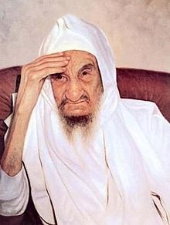

Rav Yisroel Abuchatzera, zt”l, the Baba Sali, was a holy and pure Tzadik. When he moved to Eretz Yisroel in 1951, he settled in the small town of Netivot, and he was hosted by R’ Chazan Dehahn, a righteous person who had arrived two years earlier.
The Baba Sali spent several weeks in the Dehahn home before he relocated to Yerushalayim, and the sense of appreciation and thanks that the Baba Sali had towards R’ Chazan Dehahn was incredible.
The Baba Sali’s custom was to serve elaborate meals to those who came to him for advice or Brachos, however, he did not do this during the Three Weeks from Shiva Asar B’Tamuz through Tisha B’Av, because of the spirit of mourning that overcame their home. The Baba Sali would receive visitors on a limited basis, but would not serve them a meal.
Once, during the Nine Days, a visitor who was distantly related to the Abuchatzera family, arrived at the Dehahn home with a request to see the Baba Sali, who at the time was staying in Yavneh. They told the visitor that the Baba Sali’s practice was not to greet visitors during this period, but the individual insisted on going to see him, explaining that he was on a tight schedule and had to leave immediately after Tisha B’Av.

Warmly Greeted by the Rebetzin
R’ Chazan relented and he took the man to see the Baba Sali, where they were warmly greeted by the Rebetzin. The sage was not happy about their arrival, because he was not able to serve an elaborate meal to such distinguished guests, as it did not go along with the atmosphere of mourning.
The Rebetzin, however, said to the Baba Sali that that day was the Yartzeit of the Ari HaKadosh, zt”l, and he could commemorate the day with a Seudah in honor of the Yartzeit, and invite his guests to join him. The Baba Sali was pleased with the suggestion, but he still felt that a quickly-prepared dairy meal was not a satisfactory substitute for the type of meat dinner he would normally have served these guests.
He felt that he was indebted to R’ Chazan. He served them a dairy meal, but afterwards, he asked his guests to return for a Seudah on Shabbos, and also for the meal following the fast of Tisha B’Av. The guest said that he had a tight schedule and he had to decline, but R’ Chazan agreed to attend.
During the meal, R’ Chazan noted that the Baba Sali was unusually sad. He thought that this was due to the fact that Shabbos was actually Tisha B’Av and the Tzadik was beside himself in sorrow, but after he asked some of the family members, he discovered that even when Tisha B’Av coincided with Shabbos, the Baba Sali would never change his joyful demeanor. Shabbos was Shabbos!

Why Was the Sage so Perturbed?
R’ Chazan asked the sage why he was so perturbed. The Baba Sali replied that he had a dream that night which warned of tragedy, but he refused to divulge what he dreamed so that he would not disturb the joy of Shabbos. That night, following Kinos, the Baba Sali and his entire family gathered in his private study and listened to the Tzadik relate the sorrowful events of his dream. He revealed that he had seen a fire burning, and that the fire represented the passing of his daughter-in-law in France.
Several hours later, the tragedy was confirmed. Following the fast on Sunday evening, crowds of people lined up to offer their condolences to the family. Each of these individuals received the Baba Sali’s personal attention and appreciation.
As soon as R’ Chazan entered the room, the Baba Sali quickly arose and asked him to join him in the kitchen. The Baba Sali said, “You must be hungry and thirsty following such a long fast. The family members are preoccupied with mourning. May I have the privilege of serving you?”

“The Rav Should Be My Waiter?”
R’ Chazan immediately replied, “Chas V’Shalom! The Rav should be my waiter? Baruch Hashem, I can take care of myself and I will take some food. Let the Rav go back into the room with the other mourners.”
The Baba Sali said, “I will not allow the Mitzvah of Hachnosas Orchim slip by, especially to the person who welcomed me so graciously when I first came to Eretz Yisroel. I will never forget your kindness and warmth when I had nothing with me or any home to go to.”
Rav A. Leib Scheinbaum writes, “What a powerful lesson this is in Hakoras HaTov, recognizing the good that others do. Perhaps we should ask ourselves how many people who were involved, in one way or another, in our personal development, that we have forgotten or ignored, some on purpose, and others simply through thoughtlessness?
The Baba Sali did not forget, even at a time when it would have certainly been understood that his mind was on his personal loss. But that is not how a Tzadik looks at Hakoras HaTov!

Reprinted from the Parshas Devorim 5779 email of Torah U’Tefilah as compiled by Rabbi Yehuda Winzelberg.

Shorthanded Goal

Morty Himmelman went to see his supervisor.
"Boss," he said, "we're doing some heavy housecleaning at home tomorrow, and Shirley asked me for some help with the attic and the garage, moving and hauling stuff."
"We're shorthanded," the boss replied. "I can't give you the day off."
"Thank you," said Himmelman. "I knew I could count on you!"

Reprinted from the Parshas Shoftim 5779 email of Lekavod Shabbos.
The Shema...



Parashat Va’et-hannan includes the first part of the Shema immediately after the Ten Commandments. Rambam helped us to understand the importance of saying Shema twice daily to solidify our faith in Hashem.
One of the sections in Parashat Ekev is the second paragraph of Shema, which discusses following Hashem’s commandments in times of joy as well as in times of difficulty. Hashem said to his ministering angels, “I will personally have compassion on Klal Yisrael more than any other nation, for only they coronate Me twice a day.”
Rabbi Yoel Gold told an incredible story about how even during a time of war and destruction, faith in Hashem can truly result in miracles. In 2003 during the Iraq War, Jordan Shwartz [in the American Army] was sitting on top of his Humvee patrolling a neighborhood next to the Syrian-Iraqi border. The men in his unit were driving through a marketplace that was usually teeming with people. But that Friday morning, it was deserted. Jordan felt a sense of impending doom.
He was worried about his team, and he wanted to pray that they would all make it back home safely. But Jordan was not religious at the time, and he didn’t know how to pray. All he remembered from his heritage were six words that his babysitter had taught him back when he was just seven years-old and living in New Mexico.
Jordan and his friend J.J. Jesmer were very close as children, and J.J.’s older sister, Rivka, used to babysit for Jordan. She would say the Shema with him when she put him to sleep, and she taught him that it was a prayer for protection.
As Jordan felt the sense that something was very wrong, he leaned forward and said, “Shema Yisrael Hashem Elokenu Hashem Ehad.” And as he leaned down and covered his eyes, a huge explosion went off. Some shrapnel landed in his arm because he was covering his eyes to pray. If he hadn’t been saying Shema, the shrapnel would have landed in his eyes, and he would’ve been killed.
He immediately made the decision to travel to Israel to explore his heritage after the war. He enrolled in a yeshivah, and as he was walking into the bet midrash for the first time, someone familiar crossed his path. Their eyes lit up. It was Yaakov (J.J.) Jesmer. He was to be Jordan’s rabbi in yeshivah.
Jordan’s emunah in Hashem enabled him to take that leap of faith, and Hashem orchestrated this miraculous event. The Shema is our mission statement for all Jews no matter their level of religion.
Those six words will wake all of us up as it did after the Holocaust when rabbis used the words of the Shema to bring back Jewish children that were being hidden in Christian Monasteries.
May we all realize that all the mitzvot and halachot that Hashem gave us are important, and that we should try hard to follow them to the best of our ability. May we also realize that Hashem is in control, and that as long as we follow the ways of the Torah, He will bless us beyond our greatest expectations with children, health, and parnassah.
But we must always know that it all comes from Hashem, and we must be careful not to delude ourselves into thinking that it’s our efforts that produced anything, because all the gifts that we have are truly berachot from Hashem! May we also say the Shema twice a day with complete kavanah to connect with Hashem! Amen!

Reprinted from the Parashat Ekev 5779 email of Rabbi Amram Sananes as written by Jack Rahmey To view the four minute, ten second inspirational video, please google Yoel Gold – the Babysitter’s Message.
The Lesson of the
Tavern Keeper

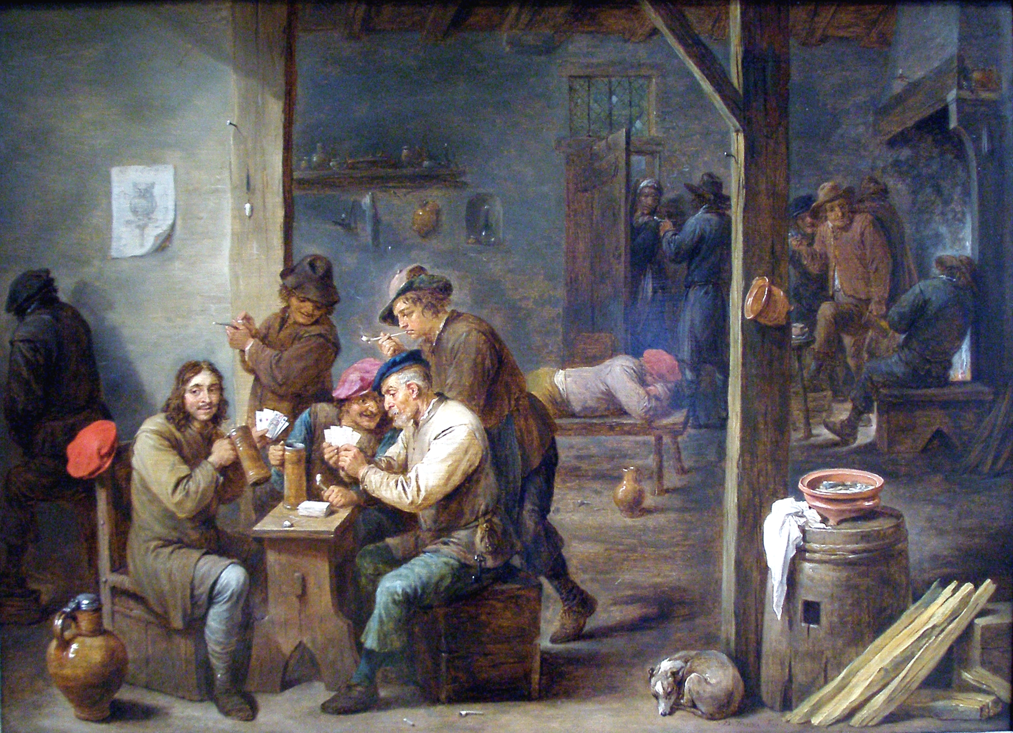

Dr. Gordio, a disciple of the Maggid of Mezritch, O”BM, was a Ba’al Teshuvah (returnee to Torah Judaism), who he had spent his early years as court physician for the king of Prussia.
He once complained to his Rebbi that he was occasionally bothered by immoral and inappropriate thoughts, a throwback to his previous lifestyle. The Maggid shared with him the following story:
Chaim, the village tavern keeper, suffered terribly from the local drunkards. They would loiter in his tavern for hours on end and use vile language, often getting quite rowdy.
As his daughters started to get older, Chaim decided that it was necessary to close down the tavern to shield his daughters from the negative influences of the coarse drunkards. It took some time for the drunkards to finally accept that the tavern was closed for good.
Every once in a while, though, a drunkard would come by and demand a drink. Chaim would very firmly tell the drunkard that he had come to the wrong place and that the tavern was no longer open. He left no room for additional pleas or arguments.
“You,” the Rebbi told Dr. Gordio, “are like that tavern keeper. Just because you were once the address for the drunkards – the immoral thoughts – doesn’t mean you always have to be. When those decadent thoughts come to haunt you, just tell them that you’ve changed and that you are not the right address anymore.” (Story and Insight by R’ Shea Langsam from “Empowerment”)
Reprinted from the Parshas Eikev 5779 email of Torah Sweets Weekly edited by Mendel Berlin.
The Coin of Eliyahu Hanavi (Elijah the Prophet)
By Basha Majerczyk

(Picture: Shutterstock)

There was once a very poor Jew who lived in Ashkelon. A G-d-fearing individual, he was always the first to arrive in the beit midrash and the very last to depart.
When Eliyahu Hanavi saw this Jew’s suffering, he couldn’t bear it. He asked Hashem’s permission to intercede and make him rich. Hashem agreed, but only on the condition that the man’s newfound prosperity wouldn’t interfere with his learning and davening (praying).
Disguising himself as a stranger, Eliyahu descended into the world and handed the man a shekel. Shekel in hand, the Jew headed out to the market but was intercepted on the way by Eliyahu, this time in the guise of a man holding a used coat. “I will sell you this garment,” he said, “for the price of one shekel.” The transaction was made.
A short time later Eliyahu approached him in the form of a merchant and offered to buy the coat for ten shekels. The poor man gladly agreed. This scenario repeated itself several times in various permutations until the original shekel had turned into an impressive sum. By the end of the day the man was quite wealthy.
This Jew became a successful entrepreneur. He continued to go to the beit midrash each day, but he was too busy attending to business matters to arrive first and leave last. In fact, if he was particularly occupied, he didn’t show up until it was too late to find a minyan, let alone recite Tehillim.
"Look what you did!” Hashem accused Eliyahu Hanavi. “See how his wealth has changed him for the worse! This was a Jew who was dearly beloved, and now you’ve distanced him from Me.” Eliyahu returned to Earth.
Approaching the now-wealthy businessman, he asked him to return the original shekel he had given him, which the latter had somehow tracked down and had in his possession. The man refused. “I’ll gladly give you 100 shekels, but not this particular one,” he replied. But Eliyahu Hanavi stood firm, insisting that this was the only shekel he was interested in.
Eventually the man gave in and relinquished it. It didn’t take long until all his wealth had disappeared. The Jew was ultimately left just as poor as he had started out. With nothing to do all day, he was once again the first man to arrive at the beit midrash and the last to depart.
He recited Tehillim with a broken heart, davened with kavanah and begged for mercy from the One Above. Finding the situation intolerable, Eliyahu Hanavi went back to Hashem and asked for permission to intervene. “But this time,” he said, “I promise it won’t have negative repercussions.” Hashem agreed.
Disguised as the person who had given him the original shekel, he approached the man and said, “I want you to know that I am Eliyahu Hanavi. It was I who gave you the shekel that made you rich. But because your wealth only served to distance you from Hashem, it was taken away. “However,” he continued, “if you promise that you will never be late for davening, I will gladly return your shekel and your wealth will be restored.”
The man promised that he would never repeat his mistakes, and the shekel was returned to him. For the second time in his life he became a successful businessman, more prosperous than ever.

Reprinted from the website of Hidabroot.com
A Powerful Story of
A Father’s Love
By Rabbi Dovid Goldwasser

“וזרקתי עליכם מים טהורים וטהרתם -- I will shower pure water upon you and you will become cleansed …” (Yechezkel 36:25)

Rav Schwadron explains the concept of this verse with the following illustration. A father wants to present his son with a special gift, but the son runs away. Disappointed, the father tosses the gift after him.
Like a wayward child who does not appreciate the kindness his father is offering him, says Rav Schwadron, we all -- at one time or another -- turn away from our Father in Heaven and do not welcome Hashem’s intention to purify us. What does Hashem do? He showers us with the purifying water. The establishment of that connection with Hashem results in וטהרתם – we ourselves set in motion the purification process and seek to return to Hashem.
A fellow Jew once called me to consult on a pressing parenting issue. The man begged me to make time for him at my earliest opportunity, because the matter was very urgent and needed immediate attention. I agreed to meet with him first thing in the morning.
The man who came into my office the next morning was deeply crushed and heartbroken. He sighed and tearfully began to tell his story.
“I was always very dedicated to my children’s upbringing,” he said. “I learned with them, paid for the best tutors, did everything possible to ensure that they would grow up to be G-d Fearing Jews. But my 17 year old son … ” he groaned, and put his face into his hands.
“You know, - with children, you need a lot of mazel. My son is completely off the path of the Torah. Shabbos means nothing to him. Yom Tov means nothing to him. I don’t even know where or with whom he spends his day.”
The man went on.
“He comes home late at night, and sleeps till noon. He doesn’t talk to us or to his sisters and brothers. I don’t think he does anything Jewish at all. My wife and I have no more joy in life,” he said. “Even our family occasions are marred - how can we rejoice when our son has nothing to do with Judaism or with us?”
“You know,” he continued, “I always wondered why Yaakov Avinu mourned Yosef for 22 years. Why couldn’t he accept the situation, and go on with life? Now I don’t wonder anymore. I can’t make peace with the situation. My own son -- my own flesh and blood, whom I raised with such love -- is going against everything I live for.”
Tears streaming down his face, the man told me that his Rabbi had advised him to speak to me.


Rabbi Dovid Goldwasser

“Rav Goldwasser,” he cried. “What should I do? What can I tell him? What can I tell my wife and other children?”
I spent a long time with him, offering encouragement and guidance, and mapping out a plan he could follow. I suggested positive steps he could take, things he could say, things he could do. I also told him what not to say and do. He asked me halachic questions, and listened carefully to everything I said.
Finally, the man arose, thanked me, and turned to go. He was at the door when he turned back.
“Can I ask the Rav one more question?” he asked.
“Of course,” I said.
“I’ve been preparing the negel vasser (hand-washing) in my house for years,” he said. “Every night, I fill the basins and put them at the foot of every bed, and every morning, I spill out the used water. It’s my special mitzvah, my special zechus. But lately, when I collect my son’s negel vasser, I see that the water isn’t used. He isn’t washing negel vasser anymore. I feel like a fool preparing it every night -- it’s just a waste of time. Should I continue preparing the water, or can I just skip it?”
The question hit me for a moment, and then I said, “If you’re asking me, I would continue to fill the negel vasser every evening.”
I could see that my answer surprised him. He seemed taken aback as he had not expected that answer.
Three weeks later, the man called to let me know what was going on. Things were pretty much the same, he said, and he was getting discouraged. I gave him encouragement, and some new suggestions.
Just before he hung up, he asked, “About the negel vasser -- do you think that I still need to bring it to his bed? I feel like such a fool every day.” Again, I urged him to continue.
Three weeks later, he called me again. This time, he could barely speak. He seemed to be crying; he was literally choking over his words.
“I listened to you, Rav Goldwasser,” he said. “I listened to you! I filled my son’s negel vasser every day, and emptied it, even though he wasn’t using it.” The man paused.
“This morning, I went to his room to collect the basin, and he was wearing his tefillin and praying!”
Overcome with emotion, he paused to catch his breath. Then he said, “I ran to him, and hugged and kissed him. It was the first time in months! I couldn’t bring myself to hug him while he was ‘gone.’ And then I asked him, ‘Tell me, my dear child, what made you put on tefillin today?’
“And my son said, ‘I’ll tell you, Dad. It was the negel vasser. You knew I wasn’t using it and, still, you refilled it every day. I saw that you never lost your faith in me. You made me feel that I shouldn’t lose my faith in Hashem, either.’”
During these holy days of the year, Hashem showers each and every one of us with purifying waters, even those who have become alienated or estranged. It is up to us to take advantage of this exceptional kindness during these auspicious days and to come forward to purify ourselves. V’tihartem!

Reprinted from the website of Hidabroot.com

